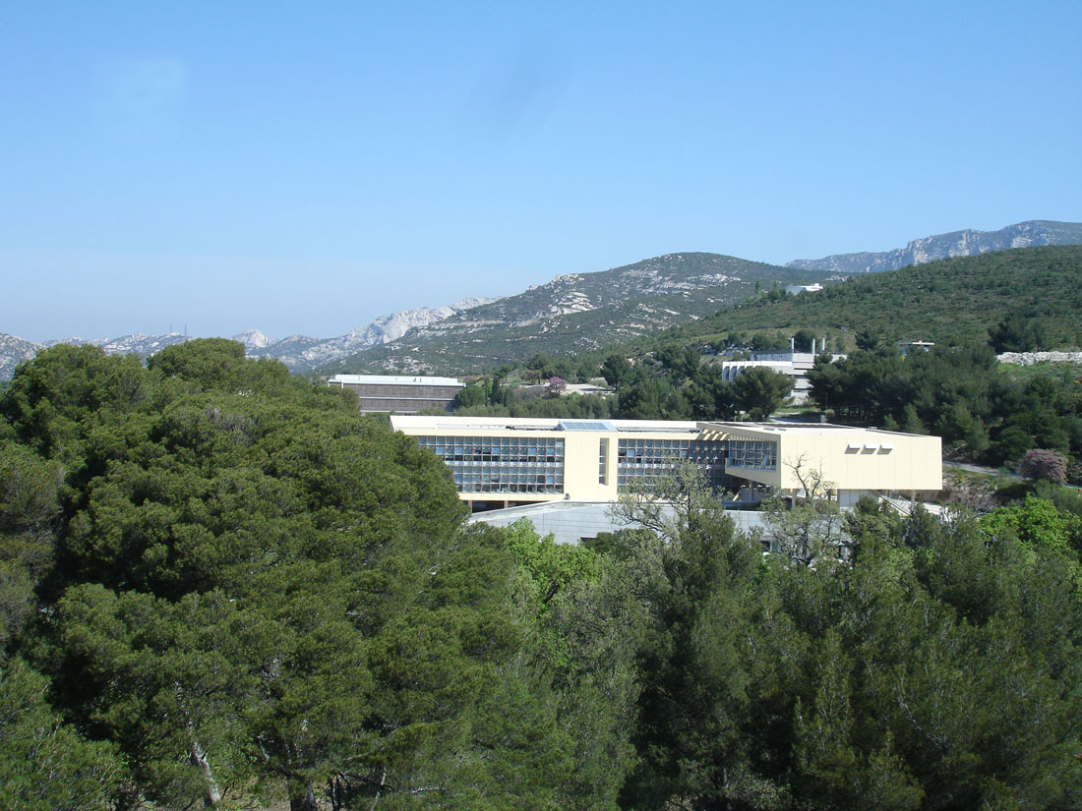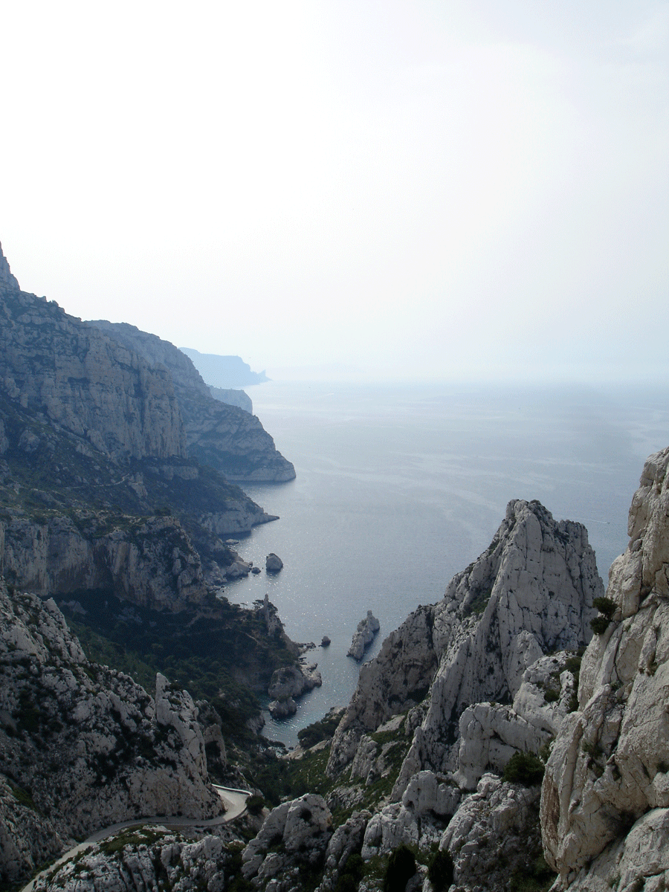

2011 CIRM Workshop: Spatio-temporal evolution equations and neural fields

Monday 24th October:

Time | Event | Speaker |  | Chair
9.30 – 9.45 | Welcome |  |  | Bressloff
9.45 – 10.30 | Dynamics of excitation and self-organization of neural fields | Shun-Ichi Amari, Riken |  | Bressloff
10.30 – 11.00 | Coffee & Tea
11.00-11.45 | Interface dynamics in planar neural field models | Steve Coombes, Nottingham |  | Bressloff
11.45 – 12.30 | Waves in random neural media | Helmut Schmidt, Nottingham |  | Bressloff
12.30 – 14.00 | Lunch
14.00 – 14.45 | Bumps in a homogenized one - population Wilson - Cowan model | John Wyller, UMB |  | Coombes
14.45 –15.30 | Mixed-mode activity patterns in a network with Mexican-hat like connectivity | Rodica Curtu,  Iowa |  | Coombes
15.30 – 16.00 | Coffee & Tea
16.30 – 17.15 | PDE methods for two-dimensional neural fields | Carlo Laing, Massey
19.00 | Dinner

Tuesday 25th October:

Time | Event | Speaker | Chair
09.00 – 9.45 | A model for the origin and properties of flicker-induced  geometric phosphenes | Bard Ermentrout, Pittsburgh
9.45 – 10.30 | Fragmented wave propagation in a subexcitable medium and its relevance for migraine pathophysiology | Markus Dahlem, Berlin
10.30 – 11.00 | Coffee & Tea
11.00 – 11.45 | Neural field model of binocular rivalry waves | Paul Bressloff, Utah
11.45-12.30 | The geometry of functional architectures underlying neural fields | Jean Petitot, Ecole Polytechnique
12.30 – 14.00 | Lunch
14.00 – 14.45 | Observing and Controlling Neural Fields | Steven Schiff, Penn State
14.45 –15.30 | Stimulus driven dynamics in neural fields | Zachary Kilpatrick  Pittsburgh
15.30 – 16.00 | Coffee & Tea
16.30 – 18.30 | Poster session
19.00 | Dinner

Wednesday 26th October:

Time | Event | Speaker | Chair
09.00 – 9.45 | Modeling sensory feedback with neural fields and linear fluctuation theory | Andre Longtin, Ottawa
9.45 – 10.30 | Nonlinear phenomena in neural fields subjected to external random fluctuations | Axel Hutt,  LORIA
10.30 – 11.00 | Coffee & Tea
11.00 – 11.45 | Biophysical mechanisms of multistability in resting-state cortical rhythms | Michael Breakspear, Queensland
11.45 – 12.30 | Towards realistic activity propagation in neural population models | Ingo Bojak, Berlin
12.30 – 14.00 | Lunch
14.00 – 14.45 | Integrative brain modeling using neural fields: theory, applications, and new directions | Peter Robinson, Sydney
14.45 –15.30 | Characterising absence seizure evolution using neural mass models | John Terry, Sheffield
15.30 – 16.00 | Coffee & Tea
16.30 – 18.30 | Free Time
19.00 | Dinner

Thursday 27th October:

Time |  | Event |  | Speaker |  | Chair
9.00 – 9.45 |  | TBA |  | Michael Buice, Austin
9.45 – 10.30 |  | Neuronal sequences and continuous attractor networks |  | Carina Curto, Nebraska
10.30 – 11.00 |  | Coffee & Tea
11.00 – 11.45 |  | New patterns of activity in an interacting pair of E-I neural field layers |  | Stefanos Folias  Pittsburgh
11.45 – 12.30 |  | Standing and propagating patterns in a neural field model with non-saturating gains |  | Yixin Guo, Drexel
12.30 – 14.00 |  | Lunch
14.00 – 14.45 |  | Prelude to Hopf bifurcation in abstract delay differential equations |  | Stephan van Gils, Twente
14.45 –15.30 |  | Coherent activity under time delays |  | Fatihcan Atay, Leipzig
15.30 – 16.00 |  | Coffee & Tea
16.30 –17.15 | Constraining the design and operation of neural field models from basic principles |  | Olivier Faugeras, INRIA
19.00 |  | Dinner

Friday 28^{h} October:

Time | Event | Speaker | Chair
09.00 – 10.00 | TBA
10.00 – 11.00 | TBA
11.00 – 11.30 | Coffee & Tea
11.30 – 12.30 | TBA

